ANIMAL

CONTROL

Barking Dogs

*Bryan Bruce*

*Animal Control Officer*

*Northwood Police Department*

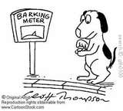

**What if my neighbor’s dog**

**is barking excessively?**

* If you would like to make a complaint concerning excessive barking in your neighborhood, you should call the Northwood Police Department - Animal Control Office during regular business hours.

* Your complaint can be anonymous however you will be asked some identifying information about yourself, and you will be asked to describe the nature of the ongoing problem, including the address of the barking dog.

* After you describe your complaint, the Animal Control Officer will contact the owner of the dog and you will be asked to keep a journal of the dog’s barking for a period of one (1) week. This record will then be turned over to the Animal Control Officer as evidence.

* If this journal shows violation(s) of RSA laws and/or the Town Ordinance, a summons will be issued to the dog’s owner and a court appearance will be made. As the complainant you may be subpoenaed to appear as a witness in court.

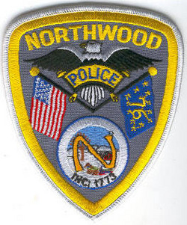

NORTHWOOD

ANIMAL CONTROL

*Bryan Bruce*

*Animal Control Officer*

*1020 First NH Turnpike*

*Northwood, NH 03261*

*Dispatch 603-942-8284*

*Office 603-942-9101*

*Fax 603-942-9102*

*BBruce@northwoodpolice.org*

## a great place to work?

* Dynamic people
* Team-oriented environment
* Exciting location
* Excellent benefits
* Competitive salaries
* Opportunity for advancement