**Animal Control Officer**

The Northwood ACO works a part-time schedule and can be reached at 603-608-9099.

Please leave a message and he will contact you during his scheduled hours.  
  
If you have questions or concerns pertaining to hunting rules and regulations in the State of N.H., please visit the N.H. Fish and Game Department's web site at [**www.wildlife.state.nh.us**](http://www.wildlife.state.nh.us) for information. They can also be reached by phone at (603) 271-3421.

**Town of Northwood - Dog Licensing Fees**

$9.00 for male or female

$6.50 for spayed or neutered dogs, or

puppies 3-7 months old.

$2.00 for dog owners 65 or older

$20.00 for group licenses of 4 or more dogs

*Rabies Vaccines are due prior to registration.*

*Dog registrations are due by April 30th of each year.*

Dogs may be licensed by mail. Just send your check,

made payable to the Town of Northwood, along with a stamped, self-addressed return envelope to

Town of Northwood, NH

Town Clerk – Tax Collector’s office

818 First NH Turnpike

Northwood, NH 03261

and we will send the licenses to you.

If you would like an e-mail reminder please advise us of your e-mail address.

Please note there is a $25.00 Civil Forfeiture fee and a late fee of $1.00 per month / per dog that is registered on or after June 1st of each year.

ANIMAL

CONTROL

Frequently Asked

Questions

*Bryan Bruce*

*Animal Control Officer*

*Northwood Police Department*

C:\Users\Frisbie\AppData\Local\Microsoft\Windows\Temporary Internet Files\Content.IE5\E2NZRHII\MC900022569[1].wmf

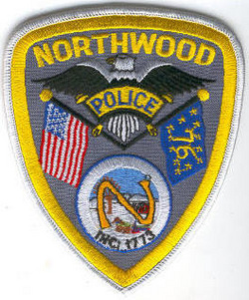

NORTHWOOD

ANIMAL CONTROL

*Bryan Bruce*

*Animal Control Officer*

*1020 First NH Turnpike*

*Northwood, NH 03261*

*Dispatch 603-942-8284*

*Office 603-942-9101*

*Fax 603-942-9102*

*BBruce@northwoodpolice.org*

## a great place to work?

* Dynamic people
* Team-oriented environment
* Exciting location
* Excellent benefits
* Competitive salaries
* Opportunity for advancement