ANIMAL

CONTROL

Living with Wildlife

*Bryan Bruce*

*Animal Control Officer*

*Northwood Police Department*

[](http://www.bing.com/url?source=images&rch=HfPqD-2VZJIIJbz-HWK57ScatwYzJmV&url=http://i597.photobucket.com/albums/tt54/SandstarofFireClan/coolwolfpic.jpg&urltarget=_blank&q=Wolf+Pics&view=detail&&id=9FA603B26E9933056761EEB4B6DC3CBB315A2649&first=0&FORM=IDFRIR&prevver=images&ssIG=8749fcb43fc5441ea71f61c1853059d8)

Information contained in

this brochure is provided

courtesy of the US Dept

of Agriculture APHIS

Wildlife Services Office

in Concord, NH. You may

contact them directly at

603-223-6832 with any

further questions.

Wild animals contribute to our enjoyment of

nature and outdoor recreation but they can also

damage property, agriculture and natural

resources and threaten human health and safety.

The Wildlife Services program of the US Dept.

of Agriculture assists in solving problems created

by wildlife.

Federal or state law and regulation protect many

species of wildlife. For information about

protected and endangered species and trapping

and relocation regulations, contact Wildlife

Services at 223-6832 or your Local State Fish

and Game office.

Equipped with the right information and tools,

most homeowners can solve their own problems

and learn to live with wildlife. For example,

trimming trees and shrubbery are ways to change

a habitat to make it less attractive to unwanted

flocks of birds or even to snakes.

The following information may assist in keeping

The curious raccoon out of the garbage can, the

Persistent rabbit or deer out of the garden, the

goose or duck out of the backyard pool, the

woodpecker off the siding and the swooping bat

out of the attic.

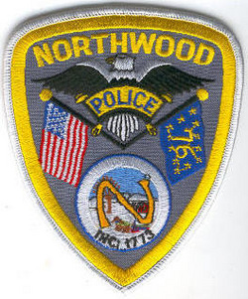

NORTHWOOD

ANIMAL CONTROL

*Bryan Bruce*

*Animal Control Officer*

*1020 First NH Turnpike*

*Northwood, NH 03261*

*Dispatch 603-942-8284*

*Office 603-942-9101*

*Fax 603-942-9102*

*BBruce@northwoodpolice.org*

## a great place to work?

* Dynamic people
* Team-oriented environment
* Exciting location
* Excellent benefits
* Competitive salaries
* Opportunity for advancement